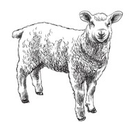
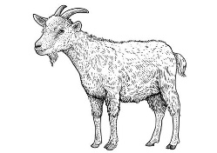
Renick Valley Meats
1340 Old Renick Valley Rd
Renick, WV 24966
304-992-4695 | renickvalley@gmail.com

Name: _____________________ Date: __________ Tag#:____
Address: _____________________________________________
Phone#: ______________ Email______________________
Animal Description: Lamb: _________ Goat: __________

Leg: Roast _______ Steak _______ Whole ________
Shoulder: Roast _______ Steak _______ Whole ________
Loin: Chops _______ Roast _______ Whole ________
Rib Loin: Chops _______ Rack ________
Ribs: Riblets _______ Whole _______
Neck: Chops _______ Roast _______

Liver _____ Heart _____ Kidney _____ Tongue _____

Cash or Check Only

